**Probability and Statistics - IT2120**

**LAB 05**

**IT24100826**

**Aluthge V K**



Q1

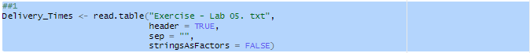

Q2

Q3

The distribution of delivery times is roughly symmetric, centered around 40 minutes. Frequencies rise towards the middle (30-45 minutes), then fall off towards the ends(20 -25 minutes and 65-70 minutes). There is no extreme skewness and the highest frequency (the “peak”) is around the 35 – 45 minute interval.

